Foothills Regional Commission Comprehensive Economic Development Strategies (CEDS) 5 Year Re-Write
Release Date: January 12, 2023
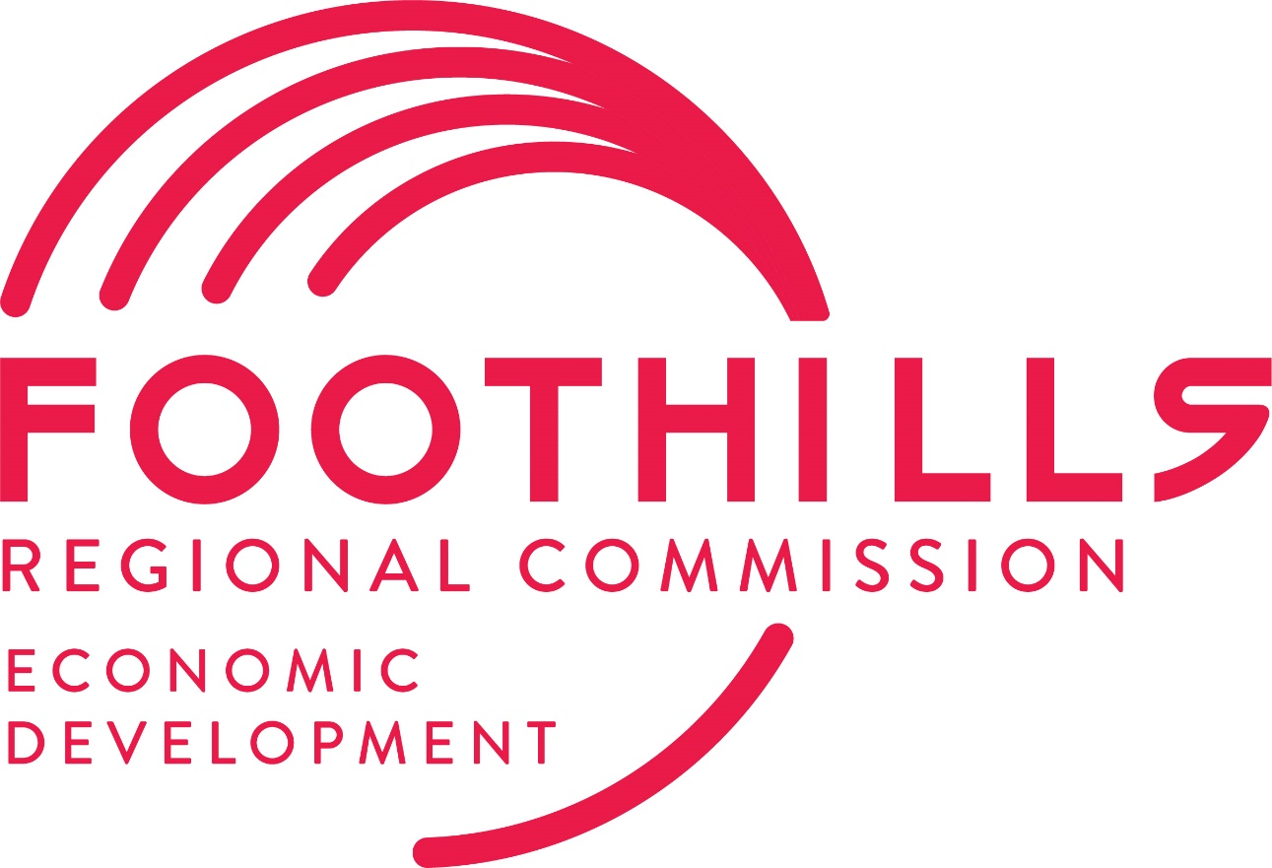

Introduction and Overview

About the Foothills Regional Commission
Foothills Regional Commission is the council of governments for the Isothermal Region which includes Cleveland, McDowell, Polk, and Rutherford Counties in Western North Carolina. The membership of the Commission consists of the local governments within the Isothermal Region.

The Commission serves its members and their citizens by fostering regional collaboration and providing professional and technical expertise. The Commission houses the region’s Area Agency on Aging, Housing Programs, Rural Planning Organization, Workforce Development Board and provides services through its Economic & Community Development and Workforce Development programs and Technical Assistance program.

Project Background
Foothills Regional Commission is the lead organization designated by the U.S. Economic Development Administration (EDA) to facilitate economic development planning and assistance in Cleveland, McDowell, Polk, and Rutherford Counties and the municipalities located therein. 2023 marks six years since the creation of the original Comprehensive Economic Development Strategies (CEDS). This project is for the creation of the 2023-2028 Foothills CEDS.

Project Scope & Tasks

Project Description & Scope
The Foothills Comprehensive Economic Development Strategies Plan will be a fundamental policy document that will help guide the region’s focus on investment and development over the next five years. A Comprehensive Economic Development Strategies plan provides a vision through the establishment of strategies, actions, and metrics to measure success.

The Foothills Comprehensive Economic Development Strategies Plan will be developed by the Council of Government (COG) using input from a board-approved sub-committee made up of a diverse group of individuals.

The COG will provide IPDC surveys and interview materials to gauge public insight. The COG will collect responses, analyze, and provide results to aid the construction of the CEDS document.
The sub-committee will have approximately six (6) meetings facilitated by The COG at the IPDC offices. Meeting agendas will go out the week prior. The first meeting The COG will review the demographic profile of the region and lead the sub-committee through a SWOT (strengths, weaknesses, opportunities, and threats) process, resiliency will also be discussed, and the meeting schedule will be reviewed.

In each of the meetings the sub-committee will be focused on topics such as, but not limited to housing, infrastructure, community development, quality of life, workforce, and marketing.

The last meeting the sub-committee will review the draft document and make suggestions for revision. In the interim, IPDC staff will meet virtually with the COG to discuss, modify, and review the upcoming sub-committee meeting agenda and materials for review.
COG staff will create a document with infographics showing applicable data within each of the strategies. IPDC’s color scheme and branding will be used throughout the document. COG staff will design the document and organize the information by the strategy to include actions and metrics. Both IPDC and The COG will work collectively to finalize the document for IPDC’s Policy Board presentation and adoption.

Maximum Budget for the Project
The maximum budget for this project is $33,000.

Timeline
The 2023-2028 FRC CEDS is expected to be completed by October of 2023.

Deliverables
The final product should include:
- A digital copy of the final report
- Three (3) hard/paper copies of the final report
- Any presentation/Steering Committee materials

Selection Criteria
Proposals from qualified firms will be examined and scored by the project steering committee based on the following attributes from the proposal:
1. Staff Qualifications
2. Responsiveness of the proposal to the scope of work.
3. COG Qualifications
4. Accurate and Efficient Timeline

Submittal Requirements and Selection Process
Prospective COGS should submit an electronic copy of their proposal with the following included:
- Agency Information
- Established Information
- Personnel
- Statement of Qualifications
- Scope of Work/Planning Process
- Cost
- Personnel Bios
- Timeline
The submittal should be no longer than ten (10) pages and should include a cover sheet. All proposals should be sent to atoney@foothillsregion.org by Friday, January 27th by 5:00 p.m

Contractual Agreement
The contract FRC anticipates awarding because of this RFP will be for a not to exceed of $33,000.

Reservation of Rights
FRC reserves the following rights if using them will be more advantageous to the FRC:
1) Withdraw this RFP at any time without prior notice.
2) Accept or reject any and all submissions, or any item or part thereof
3) Postpone proposals due date.
4) Not award a contract to any submitter responding to this RFQ.
5) Award a contract without negotiations or discussions.

Interview Process
Should the project Steering Committee decide it is necessary, COG teams may be requested to conduct an interview with the project Selection Committee

Selection Process
The Project Selection Committee will be formed from a subset of the Steering Committee, with inclusion of FRC Staff. The Project Selection Committee will score COG proposals based on the criteria outlined in this RFP. Should any consultant fail to provide any requested information or fail to provide anything requested in this RFP, the Project Selection Committee may reserve the right to disregard the consultant’s proposal.

