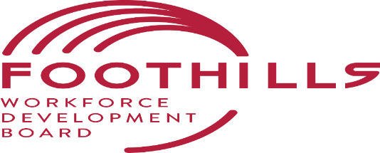
Request for Proposals--WIOA Title I Adult, Dislocated Worker, and NextGen Young Adult On-the-Job Training Program
The Foothills Workforce Development Board (FWDB) is procuring services for the Workforce Development Board is currently accepting proposals for the operation of the WIOA Title I Adult, Dislocated Worker, and NextGen Young Adults (18-24) On-the-Job Training Program in Cleveland, McDowell, Polk, and Rutherford Counties. Organizations with a history of operating WIOA programs are encouraged to apply. Completion of attached Letter of Intent Form is a requirement to participate in the full RFP process if deemed necessary. For additional information visit www.foothillsregionalcommission.org.

Geographic Area to be Served: The Foothill region includes four counties it is expected that the following counties be included together for service delivery: Cleveland, McDowell, Polk, and Rutherford

Available Funding: It is anticipated that contracts for On-the-Job Training will be a total of $50,000 for the service delivery area of Cleveland, McDowell, Polk and Rutherford, Counties.

Service Provider: The designated Service Provider will provide at a minimum. Case management WIOA Title 1 Adult, Dislocated Worker and Youth On-The-Job Training services in Cleveland, McDowell, Rutherford, and Polk Counties. Services and Award Amounts *$50,000 *Amounts are approximate and will be finalized during contract negotiations.

Purpose: The purpose of this Request for Proposals (RFP) is to solicit competitive proposals for operation of a Regional On-the-Job Training Program funded by the Workforce Innovation and Opportunity Act of 2014 (WIOA) Title I, Public Law 113-128,

Deadline for Receipt of Intent to Bid Form is 4:00 pm on July 21, 2023, by mail, email, or delivery. Late submissions will not be accepted. The completed form(s) are to be submitted to the Foothills Regional Commission (FRC), the administrative entity for the Board’s Workforce Programs to the following:

Annette Staley, Interim Director
Foothills Workforce Development Board
Isothermal Planning and Development Commission d/b/a Foothills Regional Commission
111 W. Court St.,
Rutherfordton, NC 28139
(828) 351-2369
Email Address: astaley@foothillsregion.org

Foothills Workforce Development Board Letter of Intent Form
WIOA NCWorks Career Center Operations
For Program Year 2023 (July 1, 2023, through June 30, 2024)

Through the completion of this form, our organization is acknowledging an interest to participate in FWDB’s Request for Proposal procurement process to provide services as the NCWorks Career Center Operator.

The counties listed below are open for competitive bid through a Letter of Intent in the Foothills WDB’s service area. Please indicate which county or counties your organization is interested in bidding upon through the FWDB’s Request for Proposal Process by writing or typing yes into the appropriate blank(s).

County(ies) | WIOA OJT Services
Cleveland
McDowell
Polk
Rutherford

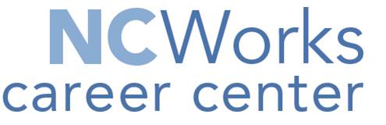
Authorized representatives of our organization have received and read the 2023 Intent to Bid specifications for the provision of WIOA Title I On-the-Job Training and we believe our organization is qualified to bid upon these services. We understand that receipt of this completed form by 4:00 pm on July 21, 2023 is a prerequisite for our organization’s participation in the FWDB’s Request for Proposal process.

Organization Name:
Address/Phone/Email:
Name & Title of Signatory Authority:
Signature/Date:

